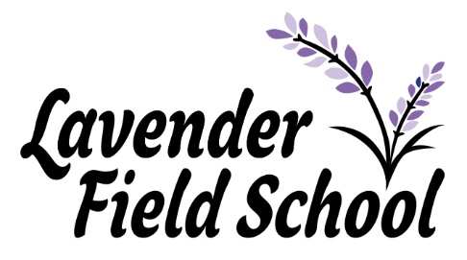
Dear Parents and Carers,

Welcome to our second newsletter of the 2020-2021 academic year. Whether you and your child are new to us, or returning after the Autumn term, we offer you a warm welcome. The children have settled in incredibly well and have begun developing friendships whilst having fun, making memories and of course, taking part in lots of learning opportunities.
The world is a different place now to what it was at the beginning of the academic year but rather than focus on that, we want to take this opportunity to focus on the wonderful, amazing things that your children have been doing over the term. The Spring term is one that has seen our pupils find new-found confidence and purpose and the aspect we have enjoyed the most, is watching our pupils learn, explore and achieve.
Perhaps a highlight of the term was World Book Day, a time to celebrate and foster a love of reading. This year children enjoyed zoom tutorials with the amazing author/illustrator, Zoe Saunders and took part in lots of exciting activities linked to her work. We know how much the pupils enjoyed this, and we were amazed to see such creative work on display – they certainly have been busy!
Another highlight this term was the charity event for comic relief, children thoroughly enjoyed throwing sponges at their staff members, the smiles on their faces were priceless! We raised a huge £56 for the charity, a phenomenal amount for a small school…Thank you!
Before I leave you to peruse the following pages, I would like to extend my thanks to you all for your patience and understanding during this difficult time. We have been navigating uncharted waters and couldn’t have done it without your unfailing support. I hope that you and your families stay safe and healthy and have a wonderful Spring Break. Happy Easter!

Thank you,

Tania, Neil, Felicity and all of the Lavender Field team.

Jubilee Newsletter
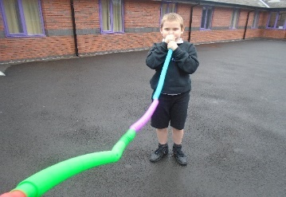
Spring 2021

We have had a fantastic spring term, and enjoyed lots of adventures.
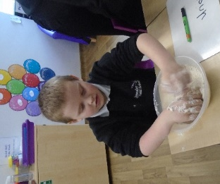
The theme this term for KS1 has been ‘Carnival of the animals’.
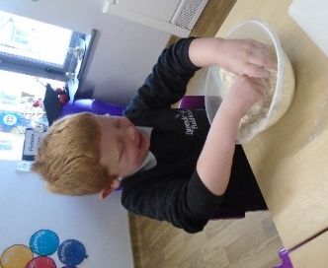
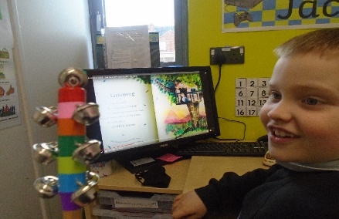
In English we have been reading the story the Little Red Han and focusing our work around the story. The boys have been retelling the story, thinking about how the story could be changed and writing sentences about the story. The boys have been working on their handwriting and sentence sequencing. We also made bread like the Little Red Hen, reading and following the instructions.
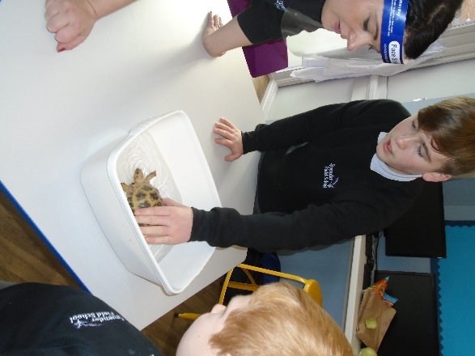
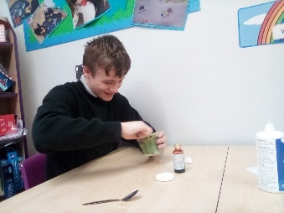
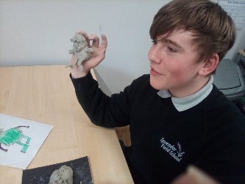
This term we have enjoyed world book day. KS3 pupils took part in a zoom tutorial by Illustrator Zoe Samuels about ‘monster’. Pupils drew their own monster, wrote a story about him and then created it from clay.
KS1 were taking part in lots of sensory activities focusing on the story Happy by Nicola Edwards. We had a great time, making noises, feeling textures, tasting foods and talking about our feelings.
We have also enjoyed science week, taking parts in lots of experiments. KS1 went for a nature walk, made an ice garden and used different materials to make their own filter among other exciting experiments.

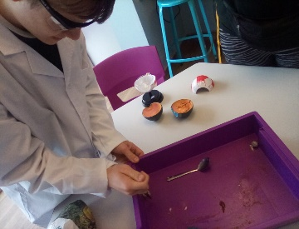
In KS3 pupils dissected a fish eye and explored acids and alkalis. The children loved being hands on and using their investigative skills.

In KS1 math’s we have been learning measurements, measuring ourselves using a meter ruler then measuring smaller items using CMS. We have also learnt about 3d shapes, their names and properties. The boys have started to learn simple multiplications and odd and even numbers. KS3 have been focusing on written methods for calculations.

Pupils have also enjoyed caring for ‘Mr. Twinkles’, feeding and bathing him. They have learnt all about how to care for animals and also enjoyed a visit from stick insects.

All the staff in Class Jubilee wish you a happy Easter and look forward to a fun filled summer term.

Felicity, Sarah, Louise, Andy and Taya.

Riviera Newsletter
Spring 2021
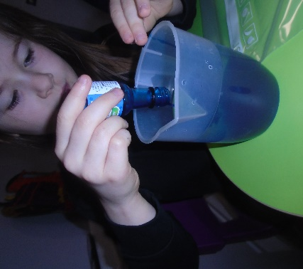
Riviera have had a fantastic spring term. We have grown welcoming lots of new children to the class and enjoyed making new friends.
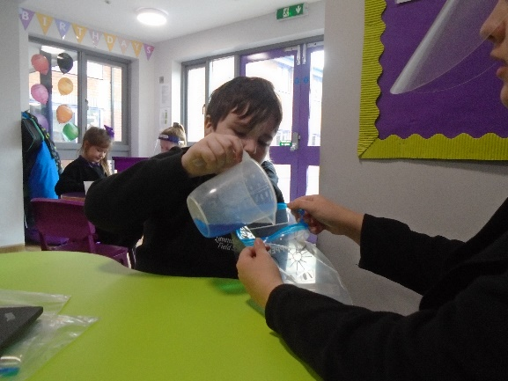
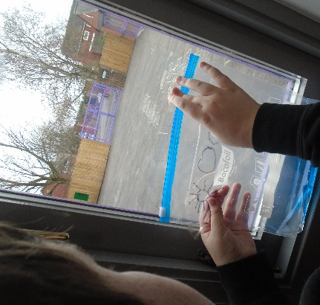
In Science, we have explored The Water Cycle. We created a water cycle in a bag to observe evaporation, condensation and precipitation happening in front of our eyes! We also practiced a water cycle song and enjoyed performing it with actions.

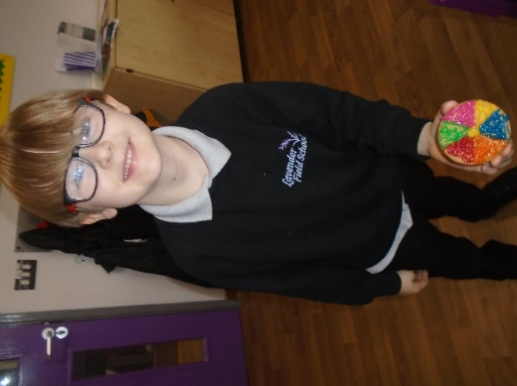
Some of the children in Class Riviera have focused on colour in Topic, and how colours can change when we add white or black. We enjoyed creating edible colour wheels to show a beautiful spectrum of colours.

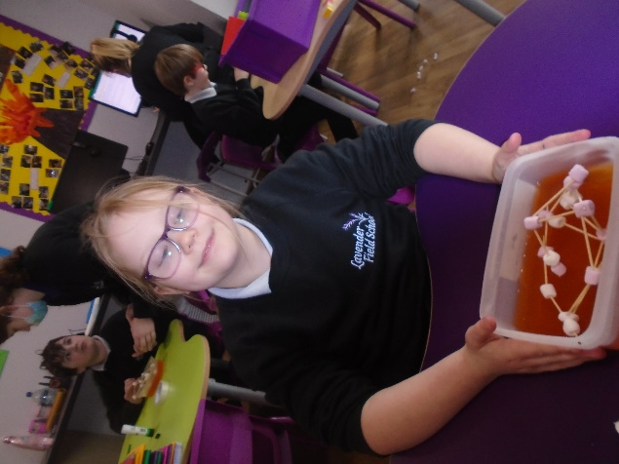
In Topic, we created earthquake proof structures in jelly. We designed and created our structures and tested if they could withstand an earthquake by wobbling the jelly!
We hope you all have a fantastic Easter and look forward to welcoming all the children back after half term.

From Mollie, Tasha. Lisa, Arthur and Yazmin

Orient Newsletter
Spring 2021
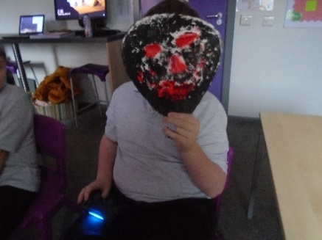
This term in Orient, we have used the theme of “Groovy Greeks”. The children have been learning about Ancient Greece in Topic. So far, we have looked at the differences between the lives of different people in Greece for our history unit. In geography, we have been learning new skills for reading maps and have created our own. In design technology we researched, designed and evaluated Greek pottery. In art, we have created Greek theatre masks which was very messy and very enjoyable!

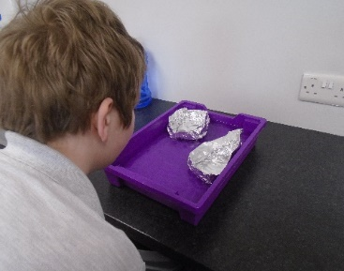
In science, we have been learning about forces this half term. We have completed lots of experiments to test gravity, friction, air resistance and water resistance.
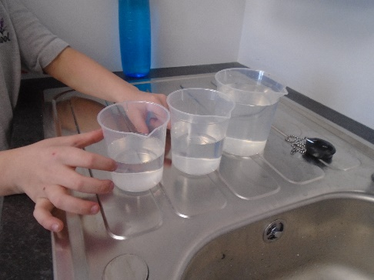

This term in English, we have been very busy and have completed lots of beautiful writing. We have covered: Greek myths, information texts, newspaper reports and poetry!
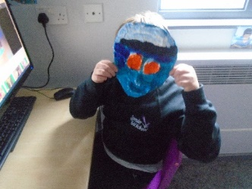
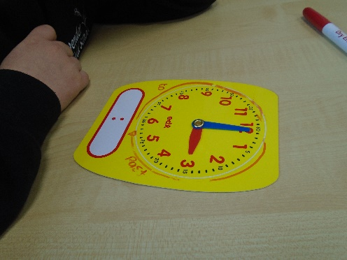
In maths we have been working on our times tables skills and have been learning about units of measurement including time.
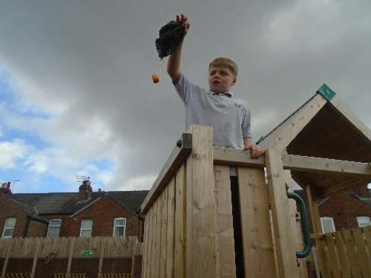
Well done to everyone for a brilliant half term. Have a safe and restful Easter.
Chloe and Rebecca

Mayflower Newsletter
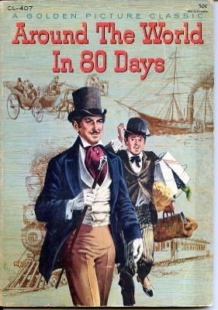
Spring 2021

The wonderful students of Mayflower have had a superb term of learning. In English we have been looking at comparing texts from different eras, considering how they are both similar or different. The students have considered what formal and informal writing can look like and considered how this language can differ.
In Maths we have been looking at looking at using money, totalling costs and figuring out how much change we would get from a set given amount of money.
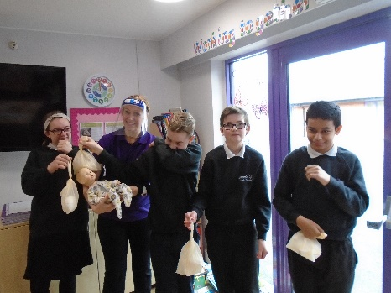
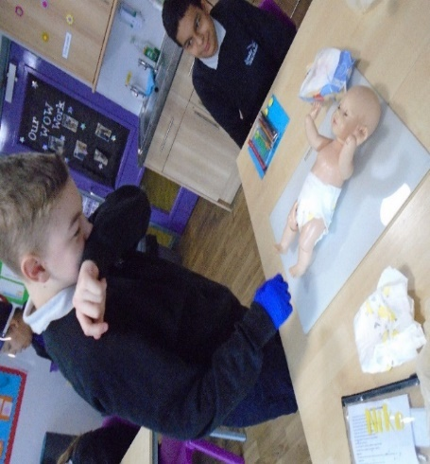
In PSHE we have been covering Sex education, and we have looked at topics such as how a baby develops in the womb, what a baby needs and how to change a baby’s nappy. The students thoroughly enjoyed changing baby May’s nappy (class doll).

The class thoroughly enjoyed the World Book Day as, we spent the whole day focussing on the book Happy, by Nicola Edwards and Katie Hickey. We enjoyed addressing the senses with a variety of different activities, including food tasting, meditation, playing with bubbles and touching various sensory items.
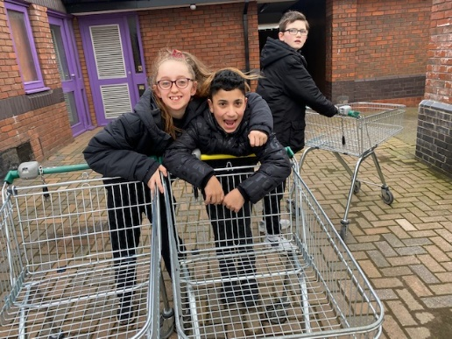
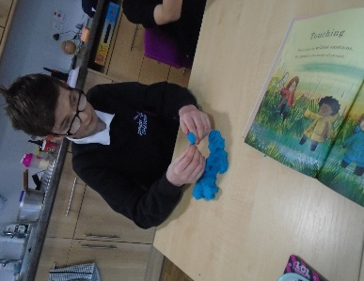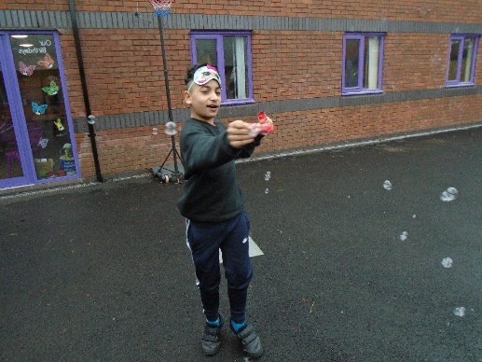
The class continue to look after the local area by collecting the trollies that have been left around the local streets and parks. We take them back to Morrisons and they thank us with lovely milkshakes and biscuits.

Happy Easter to all, from Zan, Steph, Alisa and Olivia!
Comets Newsletter
Spring 2021

Class comet have had a great Spring term. In Topic we have learnt about the Mexican day of the dead festival and created an amazing display following this.

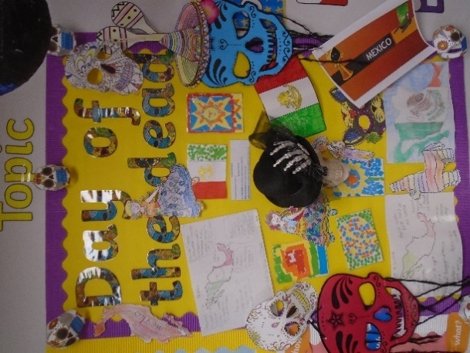

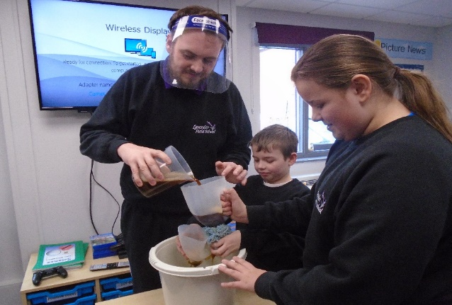
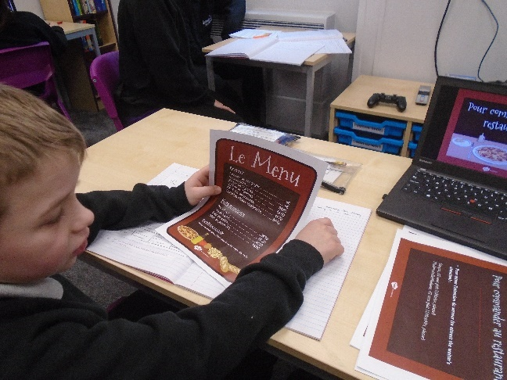
In French we have been learning about foods that we would order in various places. This means that if class comet is ever in France they can successfully order in a cinema, French restaurant and say what they like and want in a supermarket. Well done everyone!
We enjoyed World book day and pupils took part in zoom tutorials with illustrator Zoe Samuels focussing on monsters.

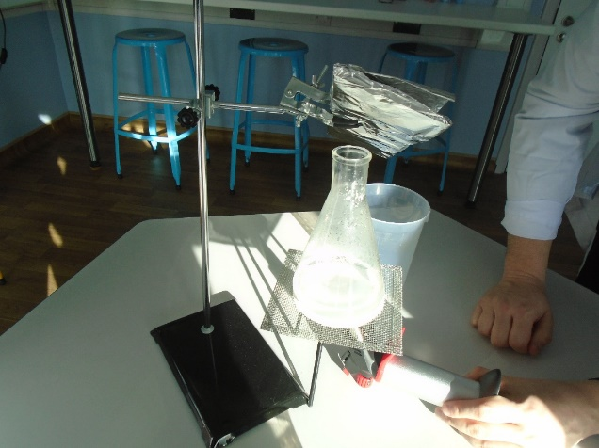
In Science Class Comet have celebrated British Science week and completed a range of experiments that have been shown on the lavender field school Facebook page. We have explored making filters that would work if we were stranded on a desert island and investigated a range of different acids and alkalis. This has meant that students have been able to taste a variety of different juices and seen what tomato sauce does to clean old rusty coins. Great work everyone!
Have a lovely Easter and we look forward to seeing you after half term!
George, Sarah, Kim and Jade

Torbay Newsletter
Spring 2021
In Maths we have focussed on many different topics, including number and pattern, calculating, geometry and measuring. Some of the children have enjoyed measuring in non-standard units by creating their own measuring device and exploring heights and lengths. Other children have enjoyed practical activities to engage their learning, such as pairing socks to learn about odds and evens. All the of the children have enjoyed using a variety of apparatus in their lessons to help develop their independent skills.
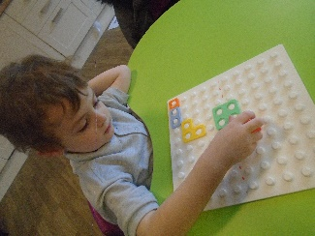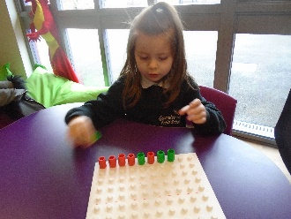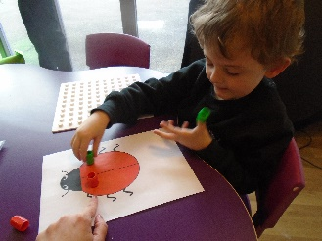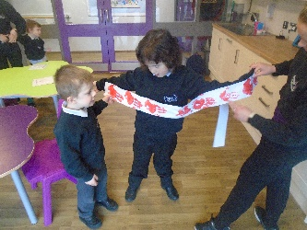
In English this term, both key stages have focussed on non-fiction. We have looked at non-fiction books about animals and even created our own information leaflets. Key stage 1 students have also looked at the traditional story ‘The Little Red Hen’ and completed lots of activities including role play, posters and captions. Key stage 2 students have also looked at poems and created our own haiku poem.
In Science this term, our KS1 Students have been learning about animals, including animal grouping, life cycles and food chains. Alongside our learning, we have grown butterflies in our classroom and watched them grow from tiny caterpillars, to chrysalises, to butterflies for us to release into the wild. Our KS2 Students have been learning the different elements of the water cycle and have enjoyed observing small experiments that show the effects of evaporation and condensation. We have created diagrams to explain the water cycle, learned a song and created the water cycle in a bag.
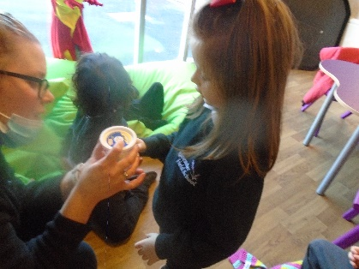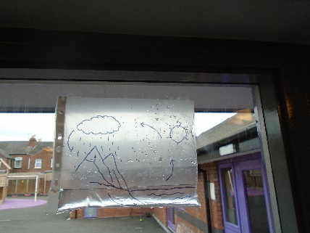
We have enjoyed many diversity days this term, including Chinese New Year, Comic Relief and Wear it Wild day. We have eagerly completed many exciting activities, but these are some of our favourites; creating fireworks in milk during British Science Week and creating owl ice cream with scrambled snake and a Gruffalo collage for World Book Day.
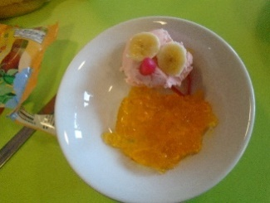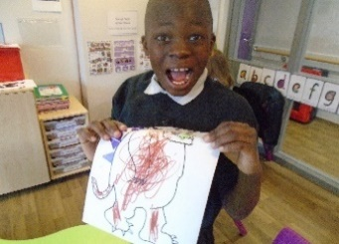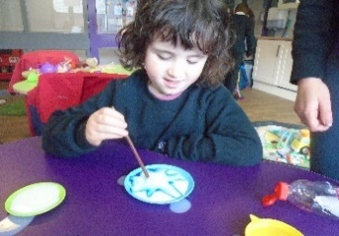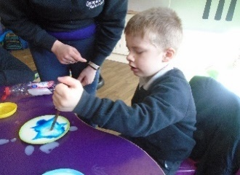

Have a great Easter from everyone in class Torbay! Nicki, Fliss and Lucy!

