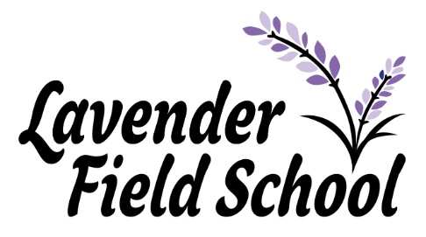

Dear Parents and Carers,
Welcome to our final newsletter of the 2020-2021 academic year. I can’t believe we have been open for a full academic year already! What a successful first year we have had together, even with the challenges that COVID has presented to us.
We have had so many highlights to share with you but perhaps one of the main highlights this term was the Queen’s birthday, a time to celebrate British values. Children enjoyed picnics in celebration of this special event. They also celebrated Pride month, and created some beautiful art work to represent diversity. This summer term, with Covid restrictions easing pupils will have the opportunity to participate in their first external reward day to celebrate all the hard work they have put in, events planned include adrenaline tubing and picnics in the park.
Thinking about the new term ahead, please can I remind you of our uniform policy which will be expected to be in place with all pupils in September and throughout the course of next year:
We have high expectations for our pupils and require them to be dressed appropriately for school. The school will issue 2 polo tops and 2 jumpers every 12 months. Should you need more, these can be ordered via our Admin team. Please ask for size options and prices. Payment is required before items can be sent home. Pupils are also expected to wear;
Formal School Trousers or Shorts (not provided by school) in black or grey with no markings (not sweatpants)
All Black School Shoes
Skirts / Pinafore Dresses or Summer Dresses (purple gingham) can also be worn but must be accompanied with cycling shorts (or similar) for modesty.
NOTE: Strictly NO jewellery, nail polish or makeup allowed.
Many of you will be aware that we welcomed a team of Ofsted to inspect Lavender field during June. The outcome, as you will have read, is that the team recognised a really positive journey over the last year, as our new school has grown and flourished. You can find the published inspection outcomes on the Ofsted website.
Finally, I would like to wish all members of the school community, students, parents/carers and staff a restful and relaxing Summer so that we are ready to face an exciting 2021-2022.
Thank you,

Tania, Neil, Felicity and all of the Lavender Field team.

Jubilee Newsletter
Summer 2021

We have had a fantastic summer term, and enjoyed lots of adventures.
KS1 in English have been reading the story ‘Brown Bear, Brown Bear What do you see?’ We have focused our work around the story. The children have been retelling the story, acting the story out using puppets and created a new character to add to the story. The children have been working on their handwriting and letter formation. KS2 children have been looking into the different types of poetry and authors then writing their own poems. KS3 pupils have worked on a unit called ‘The identity kit’ which has explored characterization.
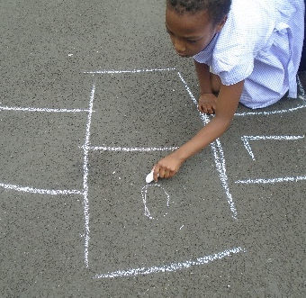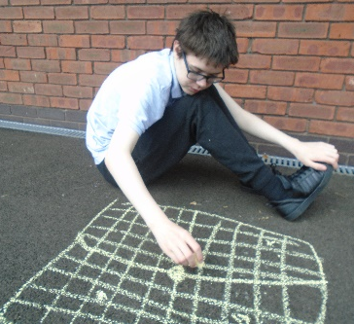
In Maths we have all enjoyed taking our work outside and using the playground to chalk on. In KS1 we have been drawing our own hopscotches and KS2 have been using chalk to write three-digit addition equations outside and KS3 have been doing large scale co-ordinates on the playground.
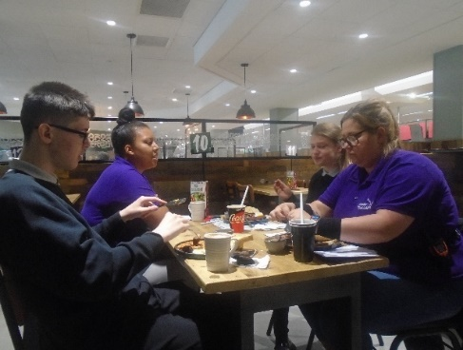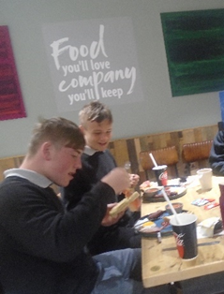
In social skills KS3 has been practicing manners and enjoyed trips into the community, particularly one involving eating an English breakfast.
This term we have enjoyed exploring and celebrating Child Safety Week and looked into how to be safe on the internet and stranger danger. We also celebrated World Chocolate Day and tried several different flavors of chocolate.
KS1 in Science have been learning about plants as food. The children have grown their own cress and tasted it. We have looked at many different herbs and used our senses to describe them, mint was the general favorite. We were very lucky and visited a fruit farm where all the children had fun picking strawberries and tasting them. In KS2 we have been investigating gravity, friction and magnets. Using fair experiments to test these and charts to record results. 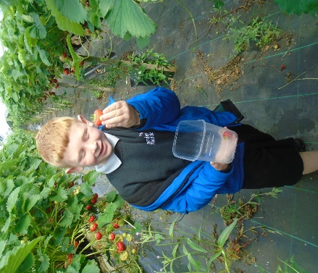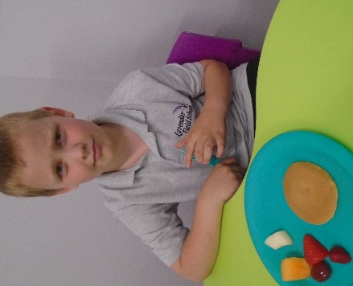
In PE We have all enjoyed swimming and horse riding this half term and it has been amazing to see their confidence grow.
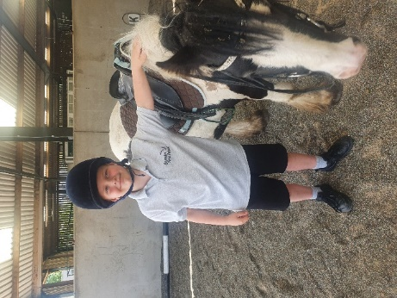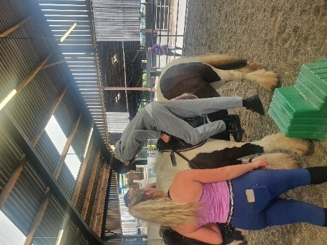
All the staff in Class Jubilee wish you a happy summer break.

Felicity, Sarah, Taya, Kim, Jade, Steph, Olivia, Alisa, Luke and Joel.
Riviera Newsletter
Summer 2021
In English this term our Key stage one pupils have enjoyed a great variety of stories. One of our favourites was ‘Whatever Next’. We have looked at character descriptions, roleplayed stories and created shopping lists for our own adventure. For our adventure, we enjoyed our own picnic on the Moon and we wore homemade space helmets. Our Key Stage two pupils have enjoyed working on the traditional story ‘Three Billy Goats Gruff’. We have explored poetry and performed in front of our peers. We have also explored non-fiction and created fact files on birds using sensory equipment.
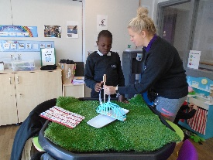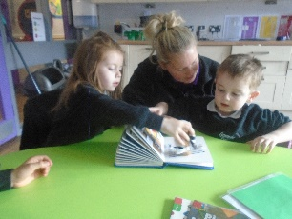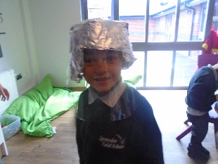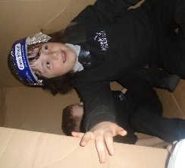
In Maths this term, we have covered lots of different topics. One which we have all enjoyed, is using language to describe position and direction. We started to use positional language when we played a game of Simon says using PE equipment before moving on to obstacle courses. The children all enjoyed giving each other detailed instructions whilst they were blindfolded and manoeuvred their way across our finish line. The children have also enjoyed covering all aspects of Maths across the term and a firm favourite is building towers to describe and compare the differences.
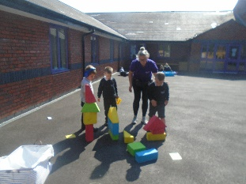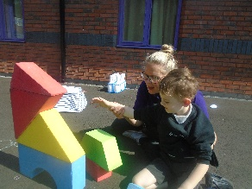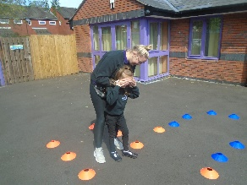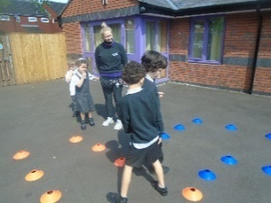
During Science, our Key stage 1 children have enjoyed exploring plants in detail. We have explored plants in our environment, observed differences between plants and also grown our own plants. The children have looked after the plants by watering them and enjoyed measuring the growth. We finally moved on to looking at how plants are used in foods and children have investigated how some foods look like plants yet others have been changed through processing. Our Key stage 2 children have enjoyed learning all about electricity. We have explored circuits and all the children have been independent in making the different elements function correctly. We looked at safety elements of electricity and the children made a safety video.

From Nicki, Yazmin, Michelle and Felicity,

Orient Newsletter
Summer 2021
During the summer term, our topic has been World War Two. In our topic lessons we have enjoyed lots of exciting activities to help us learn about the war.
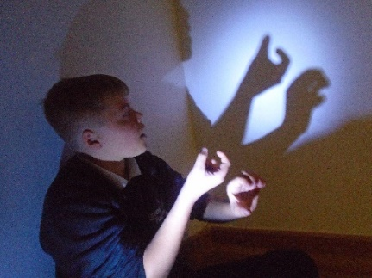
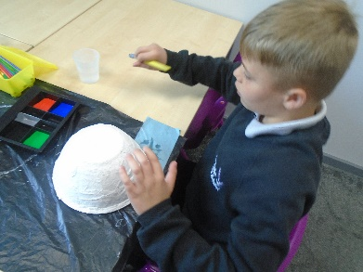
In history, we have learned about famous people like Winston Churchill and Anne Frank. In our Geography lessons we have explore maps of Europe and created our own on the playground in chalk. In art, we worked together to create an art installation as a memorial to the people who lost their lives in The Holocaust. In DT, we baked WW2 biscuits using carrots and created our own Home Guard helmets.

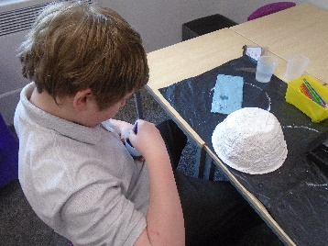
In English, we have looked at poetry and debating. We wrote our own poems about The Blitz and used some fantastic descriptive vocabulary to describe how we might be feeling.
In science this term, we have studied light. We completed lots of experiments to test how light behaves; including exploring how shadows work which was a favourite of everyone’s!

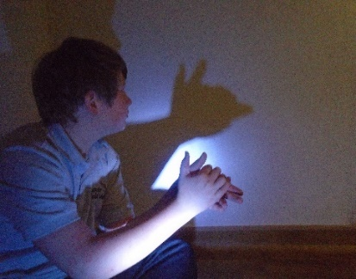

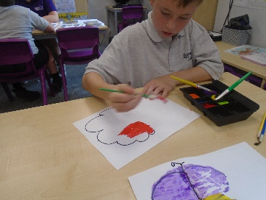
In our maths lessons we have explored number and place value and have consolidated our learning on fractions and time.
The children have worked so hard this year in Orient Class and we hope they have a very restful and enjoyable summer!
Chloe and Megan

Mayflower Newsletter
Summer 2021
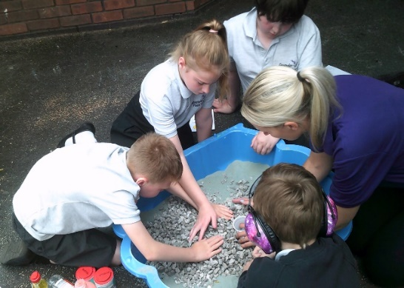
Our Topic this term has been Countries in Europe. The children have learnt all about the different climates, traditions and cultures, tasted different foods and looked at the physical and human features of the countries too. Here are some pictures of the children’s Volcano Mount Vesuvius from Italy, the children used bio carbonate of soda, washing up liquid and vinegar to represent the Volcano erupting.
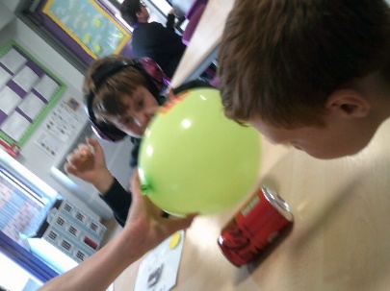
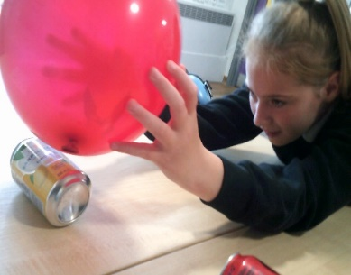
In science we have been learning all about electricity. The children have made circuits and their very own working traffic light. They have learnt all about the dangers of electricity as well as how we keep safe. We looked at different types of electricity, the children enjoyed an experiment moving cans with static electricity.
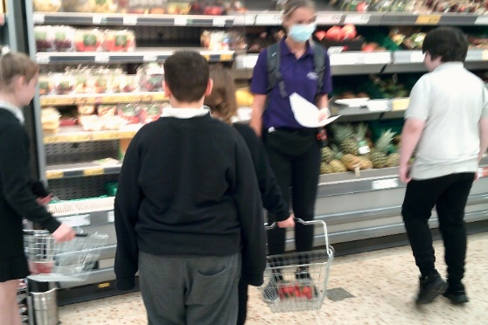
In English we have been learning to write for different purposes. The children wrote a shopping list for a picnic, we then took the list to the supermarket where we ticked off each item as we bought it. The children then enjoyed a picnic together.
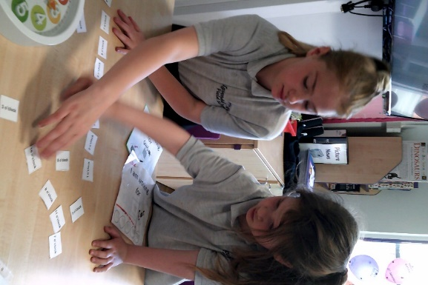
During maths we have been learning time, reading the O’clock. The children have enjoyed using large calk drawn clock outside, so they can use their own hands as the hands of the clock. The children also made time lines of their day both at school and home. We have also learnt different types of turns, quarter, half, and full. The children have enjoyed giving instructions to their friends around an obstacle course, using the different turns.
The children have enjoyed hopes and beams this term. The children have been learning basic gymnastic skills such as balancing and jumping. They have also been learning the game rounders during PE and the basic key skills to play the game such as catching.
We hope you all have a super summer and look forward to a new school year in September. Sarah, Louise and Tasha

Comets Newsletter
Summer 2021

In PE in the summer term comet have been enjoying a range of activities. This included going horse riding that we all enjoyed as seen in the pictures. Class Comet have also enjoyed playing cricket and rounders which they have all improved on and have really enjoyed also.
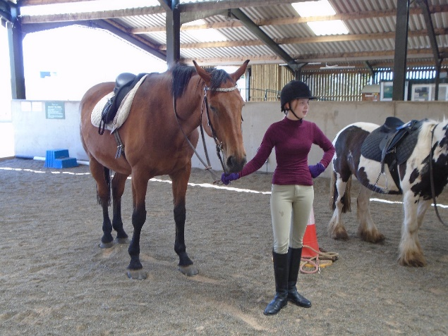
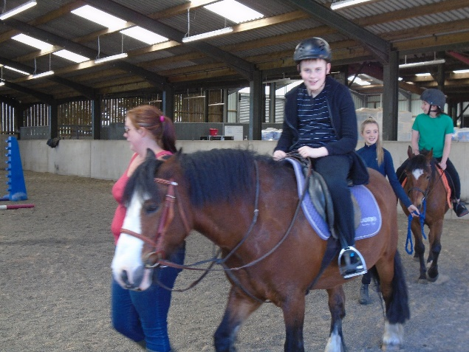
In Science class Comet have enjoyed a range of experiments. We have been looking into circuits in our electricity module which the children have enjoyed creating and adapting circuits. As seen in the pictures we have extracted electricity from lemons to make the clock work. We tried this using potato however the potatoes must of past their expiry date as the light was very dim.
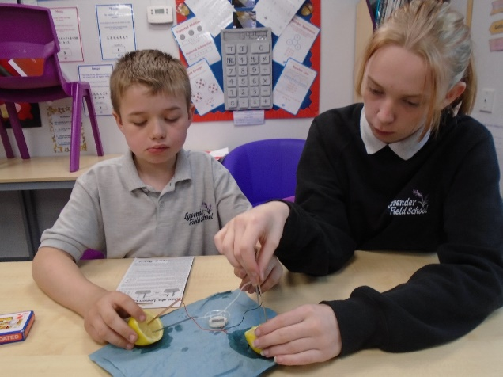
Class Comet have had a wonderful summer term. We have tried to fit in as many experiments as possible which the class have enjoyed. The class have also been enjoying lots of rewards for their good behaviour and have been given lots of prizes as they have earned lots of tokens. Well done class Comet!
George, Sarah, Kim and Jade

Rose Newsletter
Summer 2021
Wow, what a wonderful, final term for class Rose! The students have been so amazing and have made some wonderful progress, both academically and personally, I couldn’t be prouder of them.
In our English lessons, we have been looking at the World of Work. This has included writing letters of applications for their dream jobs and for a job on a pirate ship, aaargh! We then moved on to looking at interview technique. This is a hard skill to master for most people, but this wonderful class of individuals took it in their stride and put on some great performances.
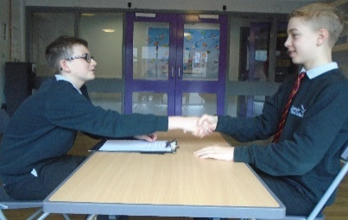
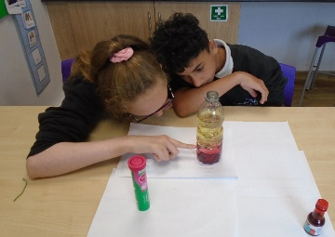
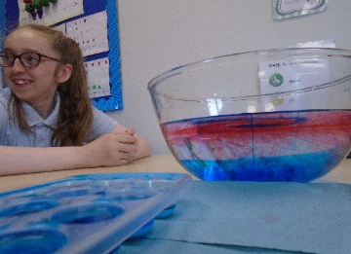
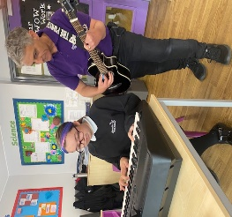
In our Maths lessons, we’ve had fun learning about directions and how to communicate these. These lessons also developed those wonderful social skills and team building skills as we worked together to achieve certain goals.

In Science we have thoroughly enjoyed looking at changing materials and their properties. We have done so many experiments, here are a few of the students’ favourites: Gas temperatures and their effect on the balloon, liquid temperatures and how they behave together, irreversible changes in cake baking and irreversible changes in sodium chloride and vinegar.
We have had lots of fun in all of the other wonderful subjects that we cover at Lavender Fields. Including; creating our own pocket games in Design and Technology lessons, visiting our local cemetery in Religious education, learning how to send emails and take better photos in ICT and many more wonderful things.
As mentioned earlier, I find it important to mention the personal progress of the students in class Rose. Some of them have been on epic journeys developing positive relationships with others, working on their social skills and personal behaviours. I would feel absolutely comfortable taking any of the class to a fine dining restaurant, knowing that they would have the most impeccable manners at the table.
As I begin to sum up my final newsletter for the year, I would like to add a colossal ‘Thank you,’ to all the parents and carers of the students in class Rose, your support and encouragement has been very much appreciated this year. Students who are supported both at home and in school, are very fortunate and are able to shine that little bit more each year.
Finally, I would like to thank all of the remarkable students in class Rose. They have made my first year at Lavender Fields one of the best in my long, teaching career. Every day they will make me laugh and smile. Many days, I have come close to tears with how proud I am of them and they continue to impress me with their progress. So, to all of the class Rose students ‘Thank you! You are amazing!’

Have a great Easter from everyone in class Rose! Zan, Mollie and Arthur!

Safeguarding Update
We know that during lockdown many of our children spent increased amounts of time on their internet-enabled devices such as mobile phones, laptops, tablets and gaming devices. The internet can greatly enrich all our lives but I would want to take this opportunity of reminding you of the harmful and abusive on-line experiences children can be exposed to, even from people they know, or they think they do!
‘Sexting’ is the term used when children and young people are encouraged to send inappropriate sexualised pictures of themselves. We know this is an increasing activity between youngsters, but rarely do they understand that they break the law when they send an indecent picture of themselves, even if it is to someone they see as their boyfriend or girlfriend. Most worryingly, they do not always appreciate that they lose control of their image the moment they press send! Chat rooms and social media platforms are favoured places for those who would wish to exploit children. Many dangerous adults hide behind convincing fake profiles and actively seek to groom children into sexual activity.
Here at Lavender Field we recognise the importance of children being safe when enjoying time on- line with their friends or playing internet-based games. We are constantly trying to educate our pupils about how to stay safe when using their devices. We would ask you all to support us by reassuring yourself that your child(ren) understand how they can keep themselves safe and checking up on who they might be talking to or communicating with. You might find the two websites below helpful, but don’t hesitate to contact me at any time if you feel you need further support with this.

Teaching Your Child about Internet & Online Safety | NSPCC
Parents Protect - Internet Safety

Many Thanks,
Tania Beales
Head of School

