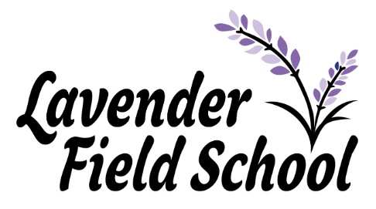
Dear Parents and Carers,

We would like to take this opportunity to thank you all for your continued support this year. Since opening as a new school in September we have enjoyed an amazing first term. We have welcomed lots of new pupils and families into the Lavender Field community and are so proud of each and every one of our amazing pupils for the hard work and dedication they have put into their new education journey.
Although the year is not ending in the way that any of us had wished for, we are so proud of the resilience shown by all our pupils in the light of Covid 19 and the incredible home learning they have achieved. Our school motto is ‘Working together to succeed’ and we would like to thank all of the parents who have helped us to achieve this by facilitating the home learning journeys that the children have been on.
We thoroughly look forward to welcoming all pupils back on Monday 4th January 2021 for the new year and are extremely excited to make more magical memories. We will continue to keep in contact via our Lavender Field School Facebook page and encourage any parents or carers who are not yet members to join our online family, where you can see updated of the fabulous work the children have been doing.
Finally, we would like to wish all of our children and families a very merry Christmas and a happy new year.
Thank you,
Tania, Neil, Felicity and all of the Lavender Field team.

Jubilee Newsletter
Autumn 2020

We have had a fantastic first term and enjoyed lots of adventures. I would like to take this opportunity to thank parents for their continued support.
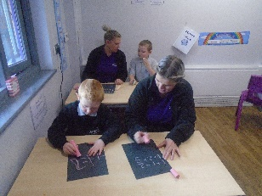
The theme this term for KS1 has been ‘Famous for five minutes’ and what a wonderful time we have had. As part of our history lessons we have focused on Queen Victoria and life in Victorian Britain. Children had fun participating in a role play of a Victorian school and exploring Victorian toys.
We have enjoyed some fun trips exploring our local area as part of social skills and even been litter picking with our local PCSO’s.
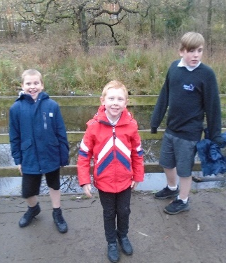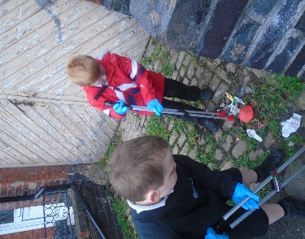
Pupils have had a great time in P.E. and enjoyed going to ‘Hopes and Beams’ and participating in lots of fun sporting activities such as archery, bowling and gymnastics.
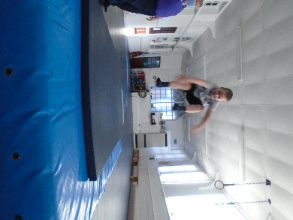
As part of social skills people have enjoyed lots of fun baking activities including making cakes, biscuits and pizzas.
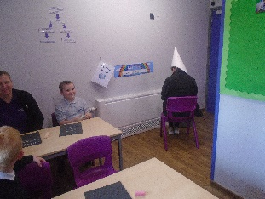
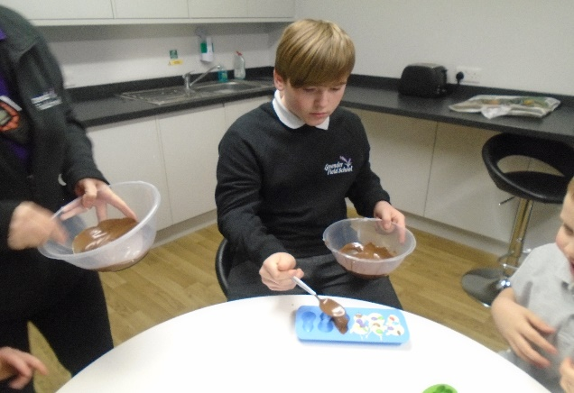

All the staff in Class Jubilee wish you a merry Christmas and a happy start to the New Year and we look forward to a fun filled 2021.

Felicity, Sarah, Kim and Luke.

Riviera Newsletter
Autumn 2020

Class Riviera have had a fabulous Autumn term. We have focused really well on our Social Skills. The children have discussed the importance of turn taking and sharing.
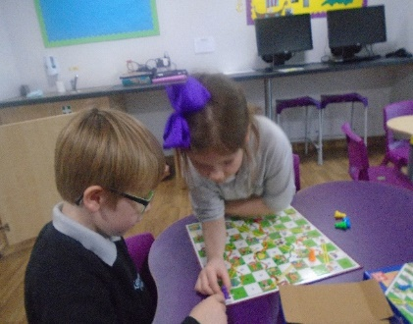
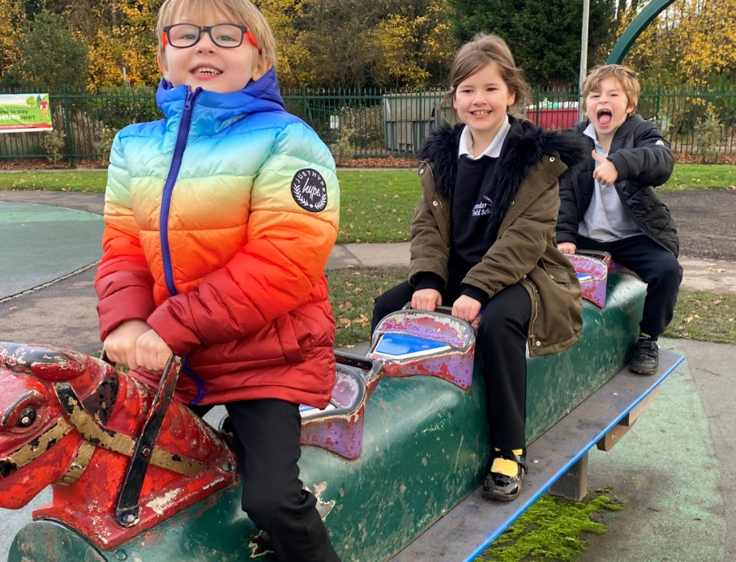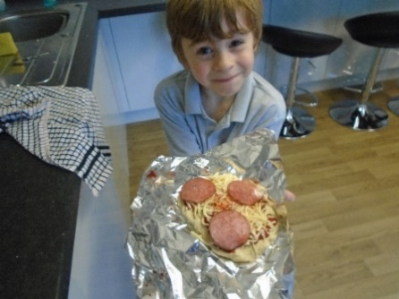

We have had lots of discussion around what makes a good friend. We have all enjoyed being good friends to each other and using kind words.
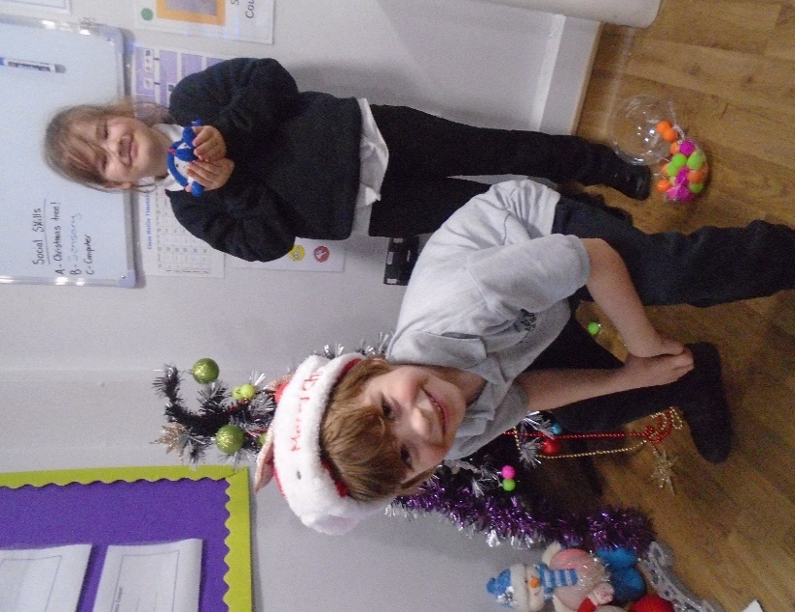
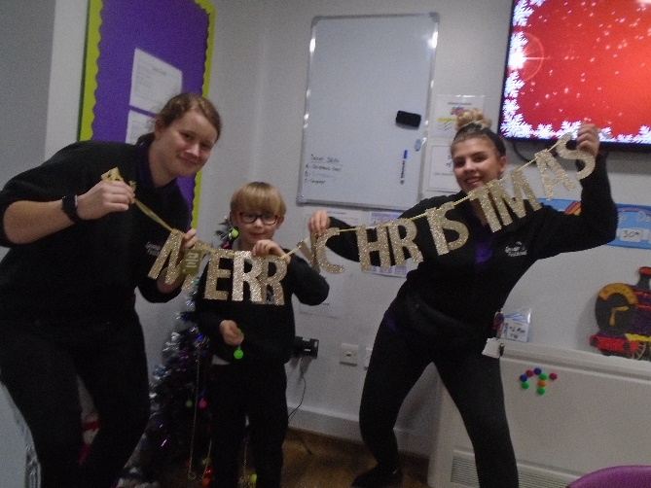

Merry Christmas from class Riviera and a happy new year!

Mollie and Tasha

Orient Newsletter
Autumn 2020
During the Autumn term, Orient have been looking at “Digging for Dinosaurs and Fossils” in our Topic lessons. We have covered lots of exciting things from comparing our lives today to Mary Anning’s life in the 19th Century to creating fossils and dinosaurs in various different ways. 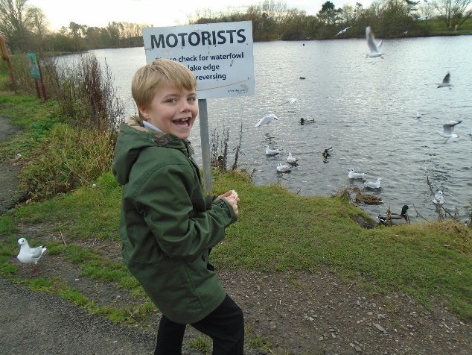
We have even managed to link this topic to our English lessons through reading the story “Dinosaurs and All That Rubbish” and discussed how we could look after our environment through writing letters to our local MP. We also linked our Science lessons to Topic by looking at how rocks and fossils are formed. We had the opportunity to replicate how rocks are formed by using chocolate in an experiment which was very fun!
In our art sessions, we have recreated some 19th Century watercolour images using watercolour pencils and made some silhouette art by studying the outline of fossils and creating the objects using black card. In our DT sessions we have been researching and building dinosaurs and focusing on their adaptations like sharp teeth and claws for a meat-eating T-Rex. But our favourite part of the term was visiting Nantwich Lake for our Geography unit where we hunted for signs of animals by looking at footprints and habitats (and sometimes other things animals have left on the ground!). 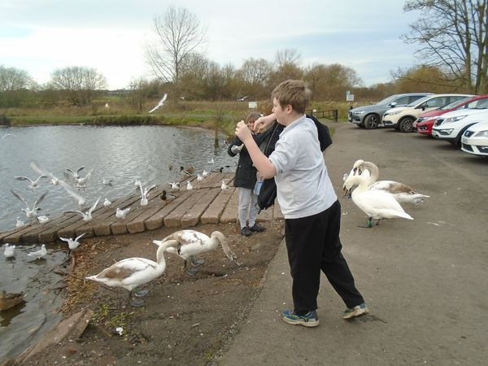
Merry Christmas to everyone from Chloe and Jade.

Mayflower Newsletter
Autumn 2020
We have had a fantastic term in class Mayflower and enjoyed lots of fun activities and learning experiences.
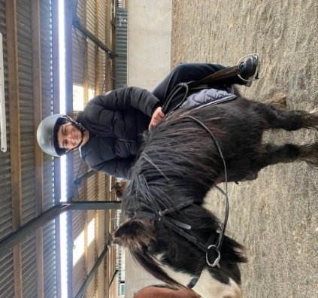
We have enjoyed our off-site P.E sessions this term. Especially horse riding; the children were a little apprehensive about touching a horse and were very nervous about riding one. They were fantastic and have all grown in confidence. They have developed their balance skills by riding with no hands. We are extremely proud of them.
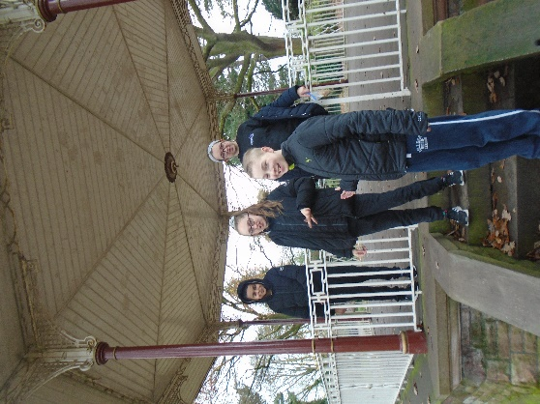
We have also visited queens park this term where we have enjoyed many social games together. We also enjoyed playing on the park equipment and feeding the ducks and geese. Some children even gained the confidence to hand feed the geese.
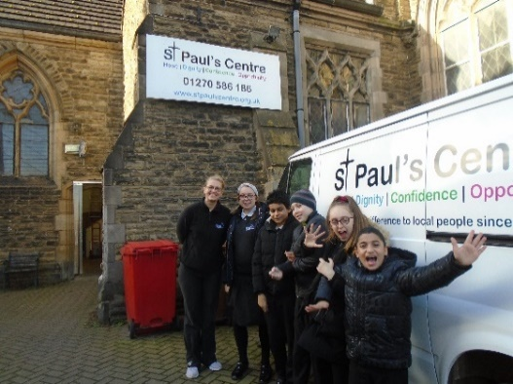

The children also took part in harvest festival food drop where we delivered our food parcels to St Paul’s Centre food bank. The children dropped the parcels inside the gate and were thanked for their donations.
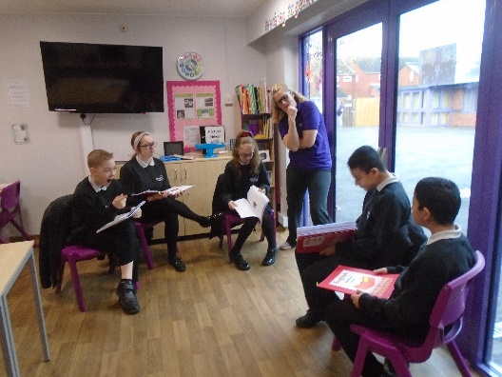
We have been learning about debating in English this term. The children have used the skills they have learnt during their English lesson to debate about phones in school. Well done for talking aloud in front of your peers.

Merry Christmas to all, from Zan, Louise and Linda!
Comets Newsletter
Autumn 2020

Comets have had a fantastic first term. We have enjoyed learning about the human body, how our joints work and exploring the respiratory system. We carried out experiments to see how to increase our heart rate and also to measure our own lung capacity.
In math’s we have been practicing our times tables and trying out new methods to complete long multiplication sums. We have also investigated the properties of shapes.
During English we have been looking at War poetry, discussing what the Poet is trying to convey, and how the use of different words can have an effect on the reader. We have also written our own Mystery stories, after looking at the key features.

We had fun learning all about space during science week, watching rocket launches, space missions and making our own planets using papier mache.
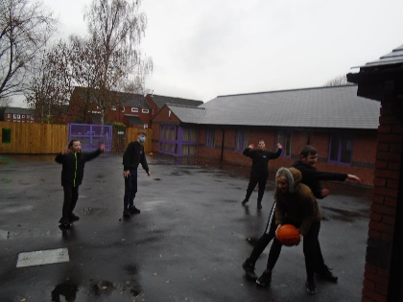
Comets really enjoy their PE sessions, this term we have been lucky enough to enjoy trampling, swimming, gymnastics and invasion games. The most recent being basketball, where the children have really improved their skills, and worked fantastically as a team.
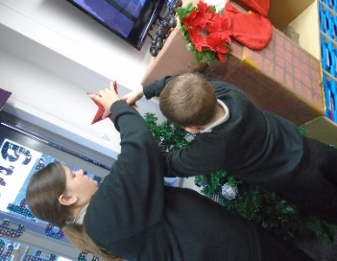
Over the last few weeks we have been getting into the Christmas spirit, decorating our room, completing Christmas themed math’s sums and other festive crafts.

All of Comet’s would like to wish everyone a very Merry Christmas!
George, Lisa and Sarah

Torbay Newsletter
Autumn 2020

What a great term class Torbay have had. The children have worked very hard in all their lessons and have particularly enjoyed hands on experiences.
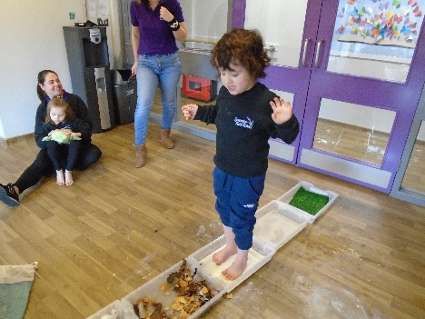
In English, they loved the barefoot trail where we allowed our creative minds to flow and the children were thinking of new descriptive words.
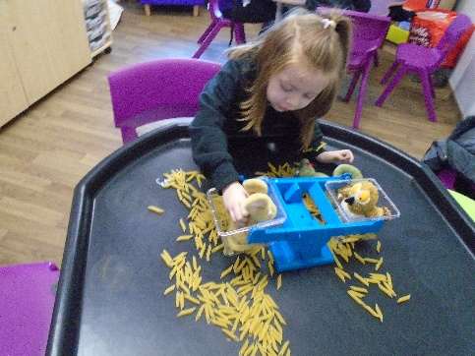
They have developed their Maths skills in different areas, including measuring, numbers and shapes and started to be aware of the different apparatus they can use.
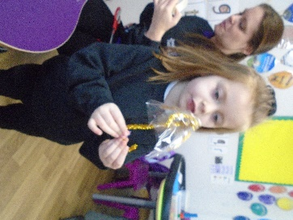
Whilst exploring materials in Science, the children have made their own curtains and umbrella by experimenting with different materials.

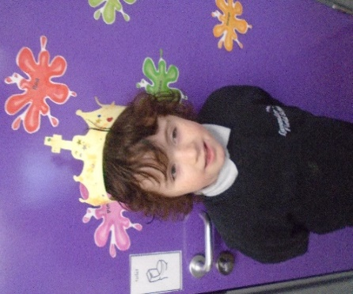
The children have enjoyed getting creative in their lessons and whilst studying Queen Victoria, they have made their own crowns.

Merry Christmas from everyone in class Torbay!
Nicki and Fliss

